**MARKAZ ARTS AND SCIENCE COLLEGE -ATHAVANAD**

**(Affiliated to university of Calicut)**

**Kerala-Malappuram-India**

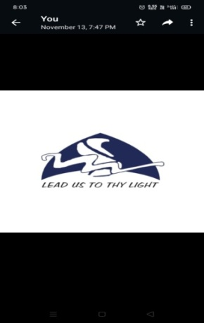

**PG DEPARTMENT OF BIOCHEMISTRY**

**COURSE OFFERED: B.Sc. & M.Sc. BIOCHEMISTRY**

**DEPARTMENT ACTION PLAN 2023-24**

|  |  |  |
| --- | --- | --- |
| **MONTH** | **WEEK/DATE** | **PROPOSED ACTIVITY** |
| JUNE(2023) | 01.06.23 | College Reopens after summer vacation  First Staff Meeting |
| 05.06.23 | World Environmental Day Programme |
| 07.06.23 | World Food Safety Day programme |
| 3rd Week | Second semester UG & PG Internal Examination |
| JULY | 1st Week | Department meeting |
| 2nd week | Practical model exam for 4th semester UG & PG |
| 3rd Week | Mock Project Presentation for final PG |
| AUGUST | 1st Week | Seminar by PG students to UG students |
| 2nd Week | Seminar on Research Methodology |
| 3rd week | Independence Day Programme |
| 4th week | Onam Celebration |
| SEPTEMBER | 1st week | Teachers Day Programme |
| 3rd week | World ozone day celebration for students |
| 3rd Week | World food day Celebration  Grievance Redressal Meeting |
| OCTOBER | First week | Gandhi Jayanti Celebration  Certificate Course meeting |
| 2nd week | Internal Exam for fifth semester  PTA meeting for 5th semester UG |
| 3rd Week | National Seminar |
| NOVEMBER | 2nd Week | World Diabetic Day Celebration |
| 3rd Week | 3rd Semester UG & PG Internal Examination |
|  | 4th Week | Certificate Course Starting |
| DECEMBER | 1st week | World AIDS day |
| 2nd Week | Internal examination for first semester UG & PG |
| 3rd Week | Seminar on IPR |
| 2024  JANUARY | 1st week | Department Meeting |
| 2nd Week | IV for Final UG & PG |
| 2nd Week | Certificate Course Mark Publishing and issue of certificate |
| 3rd Week | Republic day celebration |
| FEBRUAY | 1st Week | Department meeting |
| 2nd week | Regional webinar related to Cancer |
| 3rd Week | Internal Examination for sixth Semester UG |
| 28.02.24 | National Science Day Celebration |
| MARCH | First Week | International women's day  Grievance Redressal Cell Meeting |
| Second Week | Internal exam for fourth semester UG&PG |
| 3rd Week | PTA meeting for 4th Semester UG |
| 31.03.2024 | Department meeting  College closes for summer vacation |

DEPARTMENT OF BIOCHEMISTRY