**STUDENTS PARTICIPATION AND ACTIVITIES**

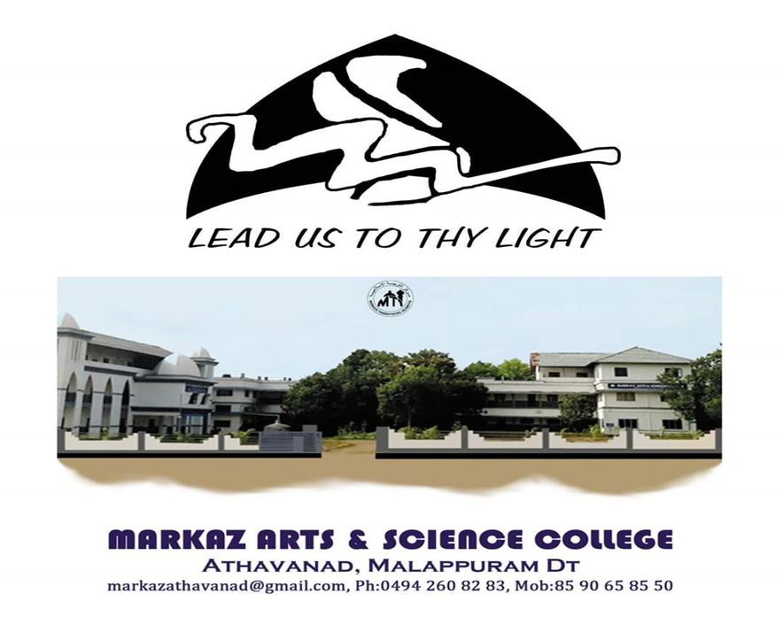

**CALICUT UNIVERSITY INTER COLLEGE BADMINTON CHAMPIONSHIP 2021-2022**

The Calicut university inter collegiate Badminton championship conducted in Regional College kizhisseri DBA Manjeri and Organized by Government college of Physical Education. It was held on 19th, 20th, 17th January 2021-22 at 9 am

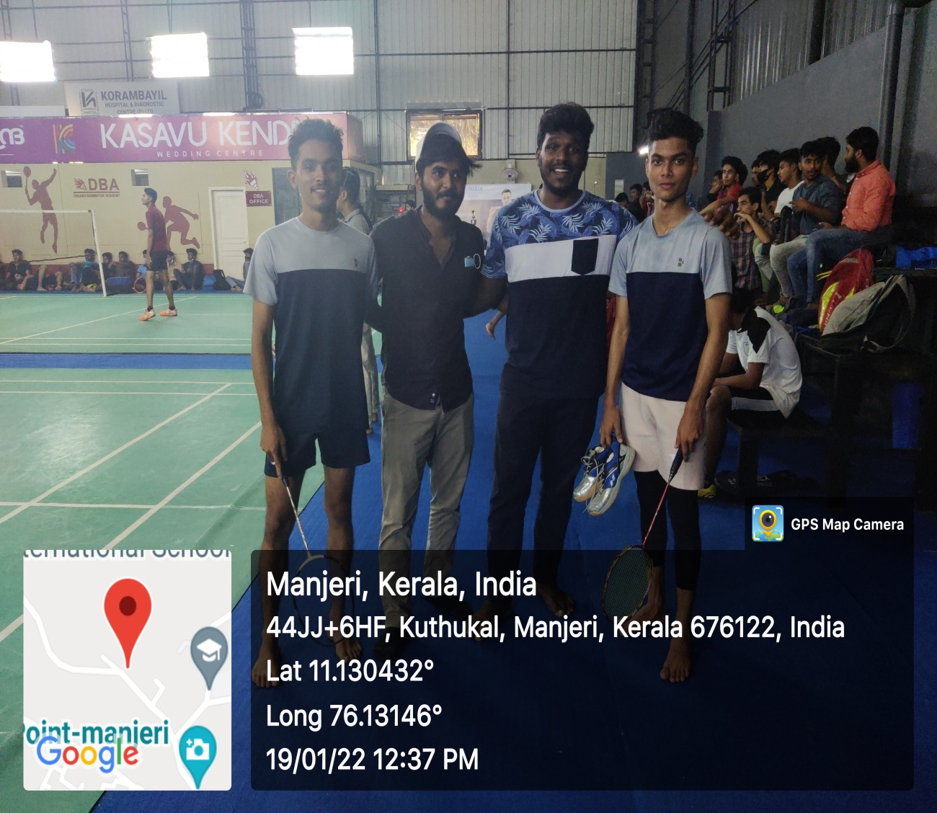

Markaz arts and science college students were participated in the programme. The college physical education Teacher, Mr. Mubasheer, was selected random students with considered their efficiency. He managed all students in the programme. All students were participated well with an effortful participation.

